Nepal College of Information Technology
Assessment
Spring 2010
Program : BE IT Time : 3 hrs
Semester : Spring (II) FM : 100
Subject : ElectronicDevices PM : 50

- Candidates are requested to give their answer as far as practicable in their own words.
- The figure in the margin indicates the full marks
- Attempt ALL question

1. a) What is diffusion capacitance? Compare with transition capacitance with required mathematical derivation. 8
b) What is breakdown diode? Explain uses of this with an example. 7

2. a) Explain emitter follower amplifier with required derivation for voltage gain, current gain input impedance and output impedance. 8
b) A silicon PN junction is formed from P material doped with 10²² accepters/m³ and N material doped with 1.2×10²¹ donors/m³. Find the Thermal voltage and barrier voltage at 25⁰C. (Given: n_{i}=1.5×10¹⁶, K= 1.38×10⁻²³ J/K, and q= 1.6×10⁻¹⁹ coulombs) 7
OR
A silicon diode has a saturation current of 0.1pA at 20º C. Find its current when it is forward biased by 0.55V. Find the current in the same diode when the temperature rises to 100º C.

3. a) Find overall voltage gain (v_{l}/v_{s}) and load voltage for the given circuit below. (Assume β=100 and r_{c}=2 MΩ). 9
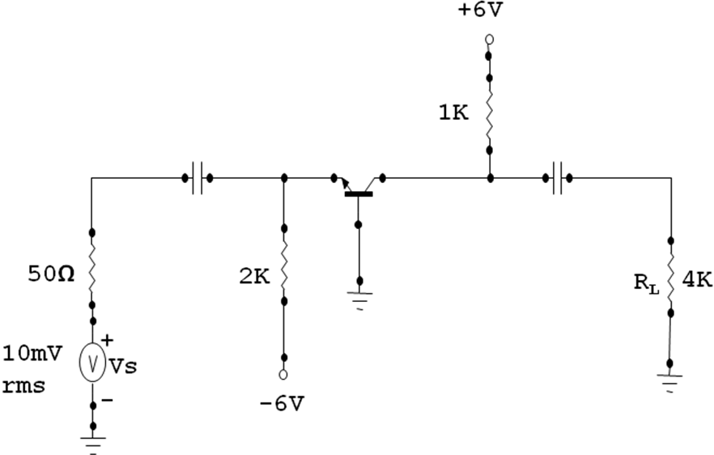
b) Explain transistor as an amplifier. 6
OR
Derive Ebers-Moll Equation for transistor.

4. a) The transistor shown in figure has the following h parameter values: h_{ie}=1600Ω, h_{fe}=80,h_{re}=2*10⁻⁴,h_{oe}=20µS.Find Z_{i} ,r_{in}(stage), A_{v}, v_{l}/v_{s} and Z_{o}(stage). 9

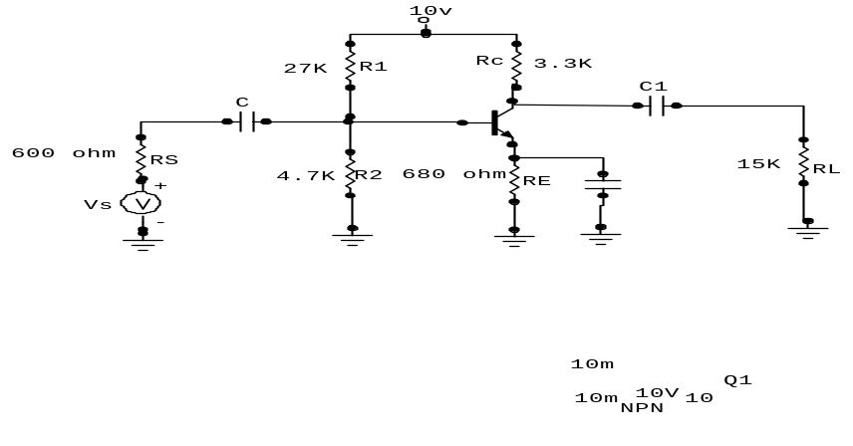
b) What is rectifier? Explain clipping and clamping circuit with an example. 6

5. a) Design a self bias circuit by using silicon transistor and resisters with β=50, V_{BE}=0.6V, V_{CC}=22.5V and R_{C} =5.6K. It is desired to establish a Q point at V_{CE}=12V, I_{C}=1.5mA and a stability factor S≤3. 8
OR
Design the self bias network of an amplifier to establish the current =1mA using power supply Vcc=+12V. (Use: rule of Thumb). 8
b) Explain operation detail of N-channel JFET, with the help of characteristics curve. 7

6. a) What are the advantages of MOSFET over BJT? Explain Enhancement type MOSFET with the help of its construction mechanism and characteristics curve? 9
b) A n-channel JFET has a pinch-off voltage -4.5Vans I_{DSS} =9mA.Find at what value of V_{GS} in the pinch off region will I_{D} equals 3mA? And what is the value of V_{DS}(sat)when ID=3mA? 6

7. Write Short Notes (any two) 2*5=10
a) Thermal Runaway.
b) UJT and its applications
c) Tunnel diode.

